# ProjectPlanningPhase

**ProjectPlanning(ProductBacklog,SprintPlanning,Stories,Storypoints)**

|  |  |
| --- | --- |
| Date | 18 October2022 |
| TeamID | PNT2022TMID32542 |
| ProjectName | Project–WebPhishingDetection |
| MaximumMarks | 8 Marks |

## Productbacklogandsprintschedule:

**ProductBacklog,SprintScheduleandEstimation(4Marks)**

|  |  |  |  |  |  |  |
| --- | --- | --- | --- | --- | --- | --- |
| **Sprint** | **FunctionalRequirement(Epic)** | **UserStoryNumber** | **UserStory/Task** | **StoryPoints** | **Priority** | **TeamMembers** |
| Sprint-1 | Userinput | USN-1 | Userinputsan URLin therequiredfieldto  checkitsvalidation. | 5 | Medium | Prasanth R |
| Sprint-1 | WebsiteComparison | USN-2 | ModelcomparesthewebsitesusingBlacklistandWhitelistapproach. | 10 | High | Poovarasi D |
| Sprint-1 | Storage | USN-3 | StoringtheBlacklistedwebsitesinDatabaseusing IBMCloud. | 15 | High | Prathaban S |
| Sprint-2 | FeatureExtraction | USN-4 | After comparison, ifnonefoundon comparison  then itextractfeatureusingheuristicandvisualsimilarity. | 10 | High | Nanthini N |
| Sprint-2 | Prediction | USN-5 | ModelpredictstheURLusingMachine learningalgorithmssuchaslogistic Regression,MLP. | 10 | Medium | Poovarasi D |
| Sprint-2 | AccuracyTest | USN-6 | Selectingthebestaccuratemodelandtoprocessfurthersteps. | 15 | High | Prasanth R |
| Sprint-3 | Classifier | USN-7 | Modelsends allthe outputtothe classifierandproducesthefinalresult. | 5 | Medium | Prathaban S |
| Sprint-3 | Hosting | USN-8 | SettingUptheApplicationandhostinginIBMcloud | 10 | Medium | Nanthini N |
| Sprint-4 | Announcement | USN-9 | Modelthendisplays whetherthewebsiteis  legalsiteoraphishingsite. | 15 | High | Prathaban S |
| Sprint-4 | Events | USN-10 | Thismodelneedsthecapabilityof retrievinganddisplayingaccurateresultforawebsite. | 10 | High | Prasanth R |

**ProjectTracker,Velocity&BurndownChart(4Marks)**

|  |  |  |  |  |  |  |
| --- | --- | --- | --- | --- | --- | --- |
| **Sprint** | **TotalStoryPoints** | **Duration** | **SprintStartDate** | **SprintEndDate(Planned)** | **Story PointsCompleted (as onPlannedEndDate)** | **SprintReleaseDate(Actual)** |
| Sprint-1 | 20 | 6Days | 24Oct2022 | 29Oct2022 | 20 | 29Oct2022 |
| Sprint-2 | 20 | 6Days | 31Oct2022 | 05Nov2022 | 20 | 05Nov2022 |
| Sprint-3 | 20 | 6Days | 07Nov2022 | 12Nov2022 | 20 | 12Nov2022 |
| Sprint-4 | 20 | 6Days | 14Nov2022 | 19Nov2022 | 20 | 12Nov2022 |

## Velocity:

Imagine we have a 10-day sprint duration, and the velocity of the team is 20 (points per sprint). Let’s calculate the team’s average velocity (AV) per iterationunit(storypointsperday)

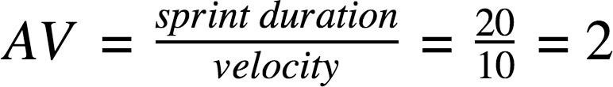

We have a 6-day sprint duration, and the velocity of the team is 20 (points per sprint). So our team’s average velocity (AV) per iteration unit (storypoints perday)

# AV=(SprintDuration/Velocity)=20/6=3.33

## BurndownChart:

A burn down chart is a graphical representation of work left to do versus time. It is often used in agile [software development](https://www.visual-paradigm.com/scrum/what-is-agile-software-development/) methodologies such as [Scrum](https://www.visual-paradigm.com/scrum/scrum-in-3-minutes/).However,burn down chartscan beapplied toanyprojectcontainingmeasurable progressovertime.

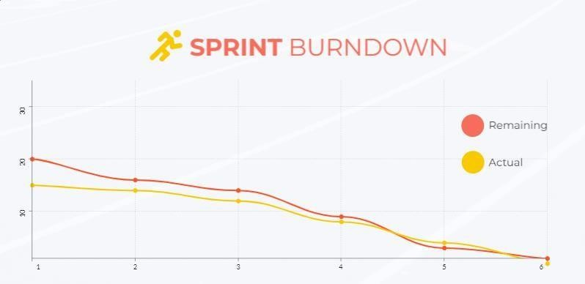

## Reference:

**https:[//www.visual-paradigm.com/scrum/scrum-burndown-chart/](http://www.visual-paradigm.com/scrum/scrum-burndown-chart/)https:/[/www.visme.co/templates/charts/sprint-burndown-chart-1425285230/](http://www.visme.co/templates/charts/sprint-burndown-chart-1425285230/)**